Practical No. 3
Aim : 7) WAP to calculate surface volume and area of a circle.

Name : Danish Altaf Solkar | Class : CO - B
Enrolment no. : 24111590805 | Batch : 2

Code :-
pi=3.14159
r=float(input("\nEnter radius: "))
h=float(input("\nEnter height: "))
volume=2*pi*r*(r+h)
area=pi*r*r*h
print("\nVolume is: ",volume)
print("\nArea is: ",area)

OUTPUT :-
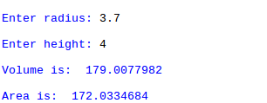

Process related  (30) | Product related  (20) | Total Marks  (50) | Signature

